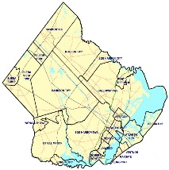
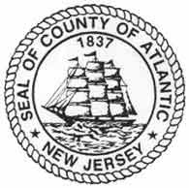

Atlantic County
NEW JERSEY
Office of the County Clerk
Joseph J. Giralo
5901 Main Street, Mays Landing, NJ 08330
Phone: (609) 625-4011 Fax: (609) 909-5111

Available School Board Seats for the 2026 General Election
Information supplied by the business administrators of each Atlantic County school district.
 | Office | Seats | Term | Years
Absecon | Local | 2 | Full | 3
Atlantic City | Local | 2 | Full | 3
 |  | 1 | Unexpired | 2
 |  | 1 | Unexpired | 1
Buena Borough | Buena Regional | 1 | Full | 3
Buena Vista Township | Buena Regional | 2 | Full | 3
 |  | 1 | Unexpired | 2
 |  | 1 | Unexpired | 1
Egg Harbor City | Local | 2 | Full | 3
Egg Harbor Township | Local | 3 | Full | 3
Estell Manor | Local | 1 | Full | 3
Folsom | Local | 2 | Full | 3
 |  | 1 | Unexpired | 1
Galloway Township | Greater Egg Regional | 1 | Full | 3
 | Local | 3 | Full | 3
Hamilton Township | Greater Egg Regional | 1 | Full | 3
 | Local | 3 | Full | 3
Hammonton | Local | 3 | Full | 3
Linwood | Local | 3 | Full | 3
Longport | Local | 1 | Full | 3
Mullica Township | Greater Egg Regional | 1 | Full | 3
 | Local | 3 | Full | 3
Northfield | Mainland Regional | 2 | Full | 3
 | Local | 3 | Full | 3
Pleasantville | Local | 3 | Full | 3
Port Republic | Local | 3 | Full | 3
Somers Point | Mainland Regional | 1 | Full | 3
 | Local | 3 | Full | 3
Weymouth | Local | 3 | Full | 3
 |  | 1 | Unexpired | 2
 |  | 1 | Unexpired | 1

